B.P.H.E Society's

**Ahmednagar College, Station Road, Ahmednagar, 414001**



A

Project Report

On

“Online Food Delivery Application”

Submitted By

Priyanka Vijay Jagadale

B.B.A(C. A) – Ⅲ YEAR

Semester - VI

Year – 2023-24

Under Guidance

Of

**Mrs. Madhavi Dethe Mam**

# ABSTRACT

This project proposes the development of an online food ordering application tailored for a single restaurant, aiming to capitalize on the growing demand for digital dining solutions. The application offers a comprehensive scope of features, including user registration and authentication, menu display with detailed descriptions and images, streamlined ordering process with customization options, secure checkout and payment processing, real-time order tracking, user feedback and ratings system, intuitive admin dashboard for restaurant management, seamless integration with third-party services, localization and personalization capabilities, robust analytics and reporting functionalities, and adherence to compliance and security standards. By leveraging these features, the application promises to enhance the restaurant's operational efficiency, extend its reach to a wider customer base, and elevate the overall dining experience for patrons, positioning it competitively in the digital marketplace.

# INDEX

|  |  |
| --- | --- |
| Sr. No | Contents |
| 1. | Introduction |
| 2. | Need Of the System |
| 3. | Scope of System |
| 4. | System Requirements |
|  | 1. Software Requirement |
|  | ii.     Hardware Requirement |
| 5. | Diagrams |
|  | i   Class Diagram |
|  | ii    Object Diagram |
|  | iii   Use Case Diagram |
|  | iv   ER Diagram |
|  | v   Activity Diagram |
| 6. | System Design |
| 7. | System Testing |
| 8. | Conclusion |
| 9. | Bibliography |

# NEED OF THE SYSTEM

The introduction of this online food ordering application not only aligns with current market trends but also addresses the changing needs and expectations of consumers, who increasingly seek the convenience of ordering meals from the comfort of their homes or on the go. By providing a user-friendly interface, real-time order tracking, and flexible payment options, the application endeavors to enhance the overall dining experience while streamlining operations for the restaurant.

Furthermore, this project underscores the restaurant's commitment to embracing technology as a means of fostering customer engagement, driving revenue growth, and gaining a competitive edge in the industry.

# SCOPE OF THE SYSTEM

1) Convenience: With the hectic pace of modern life, many people don't have the time or energy to cook meals at home. Online food delivery apps offer a convenient solution by allowing users to order food from their favourite restaurants with just a few taps on their smartphones.

2) Variety: These apps provide access to a wide variety of cuisines and restaurants that may not be available locally. Users can explore different types of food and discover new dining options without leaving their homes.

3) Timesaving: Ordering food online saves time compared to dining out or cooking at home. Users can skip the hassle of traveling to a restaurant, waiting in line, and waiting for their food to be prepared.

4) Accessibility: Online food delivery apps make it easier for people with mobility issues or disabilities to access restaurant food. They can order meals from the comfort of their homes without having to navigate physical barriers.

# SYSTEM REQUIREMENTS

1)Market Growth: The online food delivery market is continuously growing, driven by factors such as urbanization, changing lifestyles, and increasing smartphone penetration. As more people become accustomed to the convenience of ordering food online, the market size is expected to expand further.

2)Geographical Expansion: Online food delivery apps are not limited to urban areas or developed countries. There is potential for expansion into suburban and rural areas, as well as emerging markets where demand for convenience is increasing.

3)Restaurant Partnerships: The scope of online food delivery apps relies heavily on partnerships with restaurants. As more restaurants join these platforms, users gain access to a broader range of cuisines and dining options, further increasing the app's appeal.

4)Diversification of Services: Beyond traditional restaurant delivery, online food delivery apps are diversifying their services to include grocery delivery, meal kits, alcohol delivery, and more. This expansion broadens their scope and makes them more integral to consumers' daily lives.

|  |  |  |  |
| --- | --- | --- | --- |
|  | ***Hardware*** | ***System Minimum***  ***Requirements*** |  |
| ***Processor*** | ***Intel(R) Core (TM) i5 CPU*** |
| ***Hard Disk Size*** | ***320 GB*** |
| ***RAM*** | ***4 GB*** |
|  | | |
|  | ***Software*** | ***System Minimum***  ***Requirements*** |  |
| ***Client Operating System*** | ***Windows 7 & Higher*** |  |
| ***Server Operating System*** | ***Windows 2008*** |  |
| ***Data Base Management***  ***System*** | ***SQL*** |  |
| ***Web Browser*** | ***Mozilla Firefox, Google***  ***Chrome etc.*** |  |
| ***Programming Languages*** | ***Java, Advance             Java*** |  |
| ***Text Editor*** | ***Spring Tool Suite*** |  |
|  | | |  |

# DIAGRAMS

**Class Diagram-:**

**Each class has attributes and methods that reflect its purpose within the system. This diagram provides a foundation for building out the functionality of an online food delivery app, but it can be expanded upon and refined based on specific requirements and features of the application.**

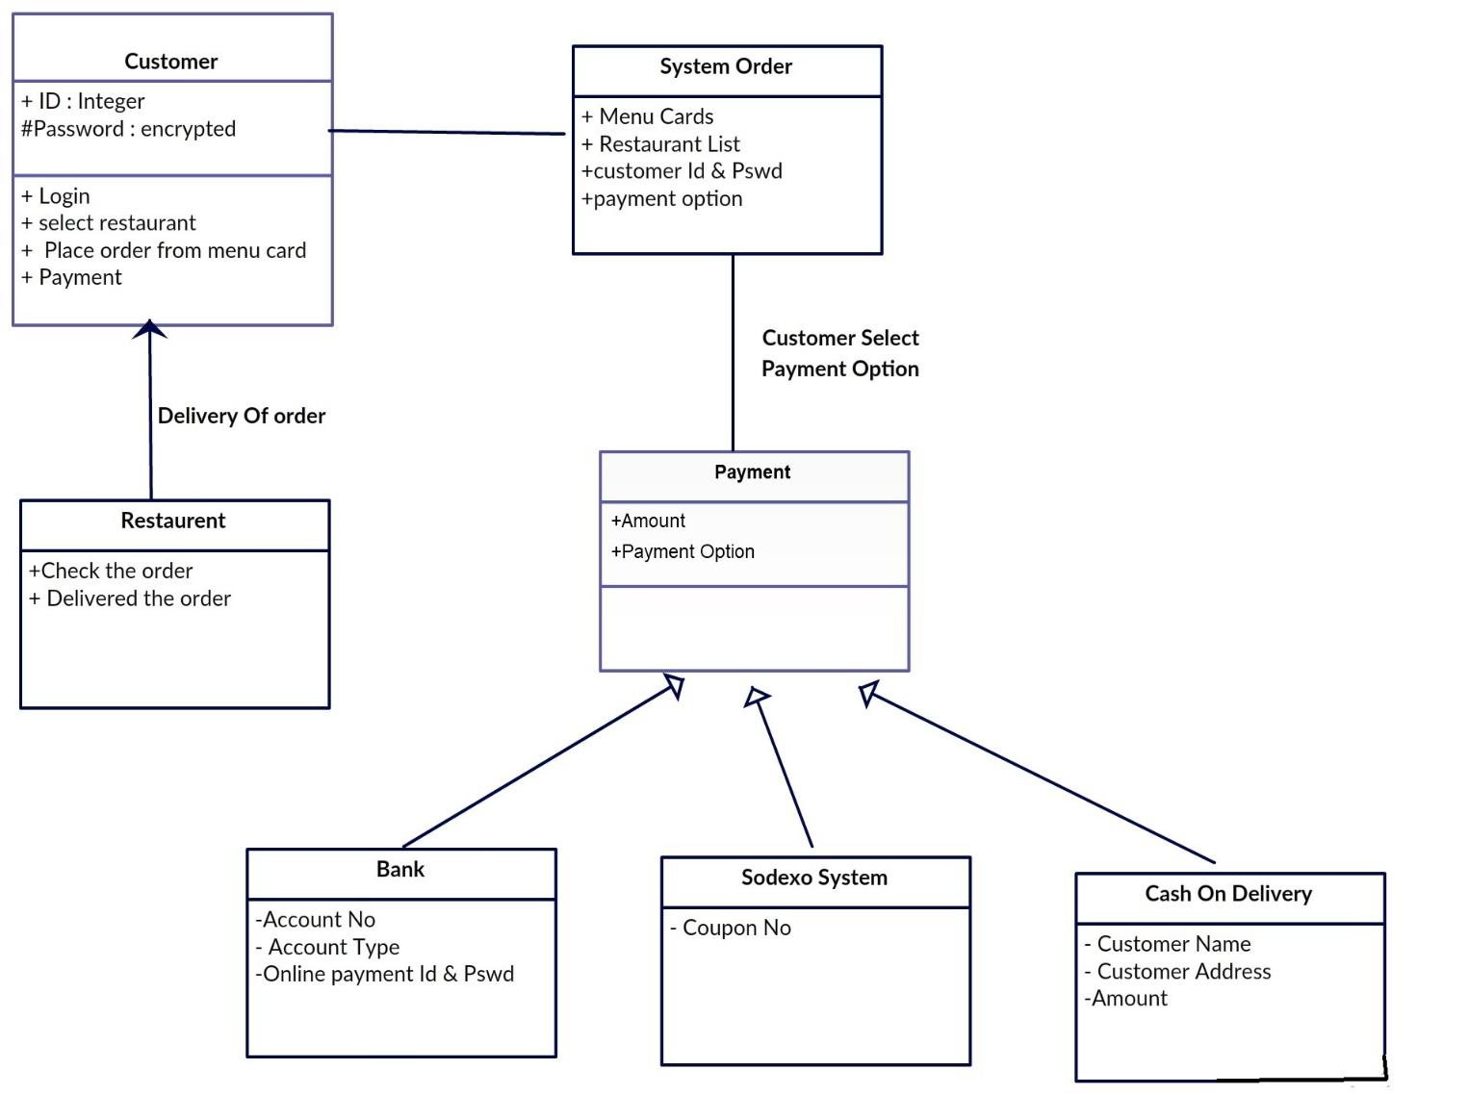

**Use Case Diagram -:**

**This diagram outlines the primary interactions between the actors and the system functionalities. However, it can be further expanded to include additional features and actors such as registration/login, payment, order tracking, etc., depending on the specific requirements of the online food delivery app.**

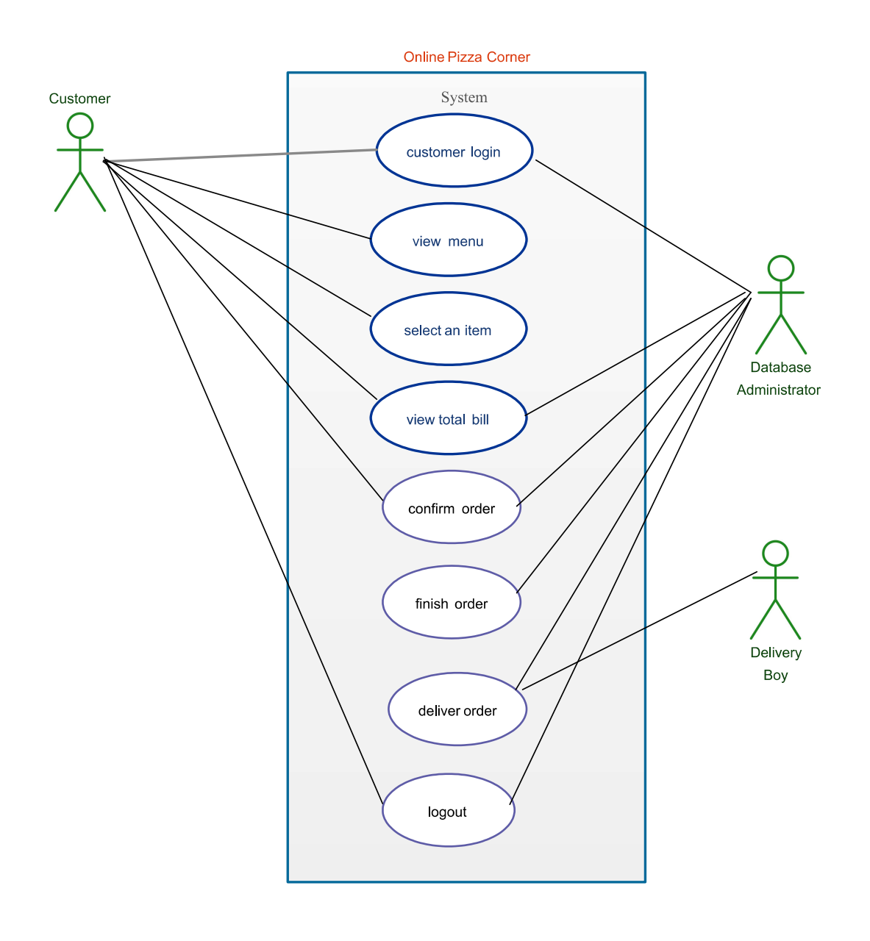

**ER Diagram -:**

**User: Represents the users of the app who place orders. It has attributes like userId (primary key), name, address, and email.**

**Order: Represents the orders placed by users. It has attributes like orderId (primary key), orderStatus, deliveryAddress, and foreign keys userId and restaurantId referring to the User and Restaurant entities respectively.**

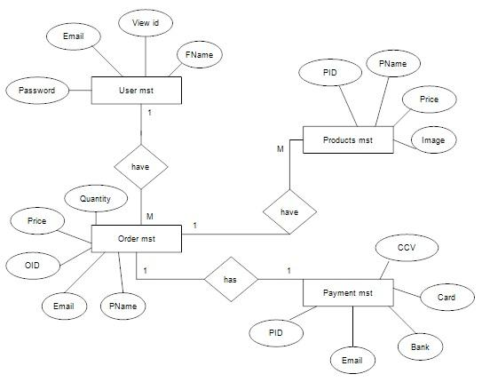

**Activity Diagram-:**

**This diagram helps visualize the flow of activities involved in the process, from user interaction to order fulfilment, in an online food delivery app.**

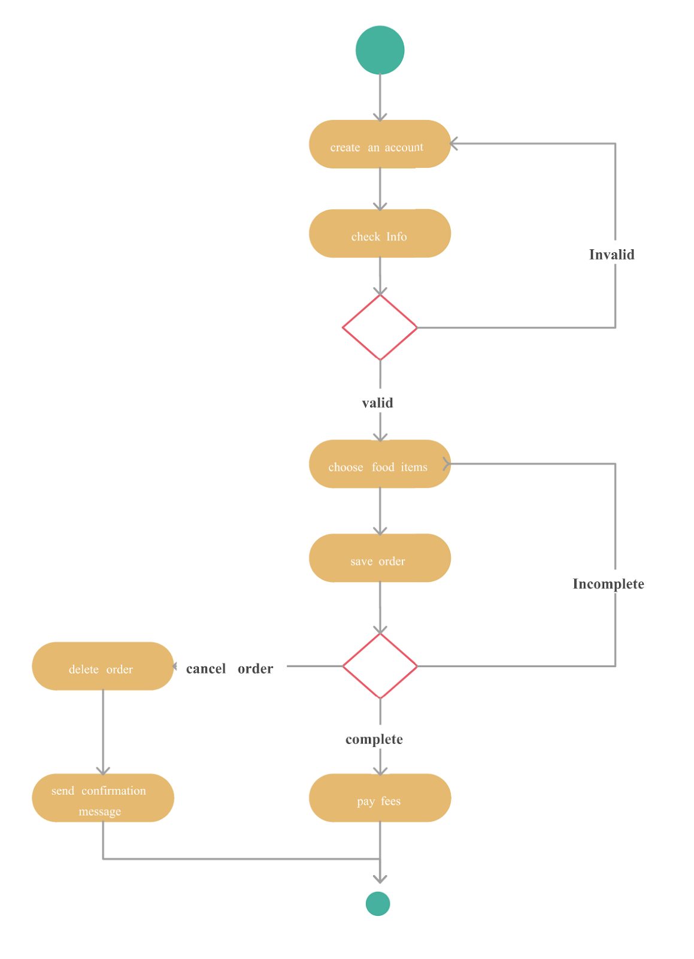

# SYSTEM DESIGN

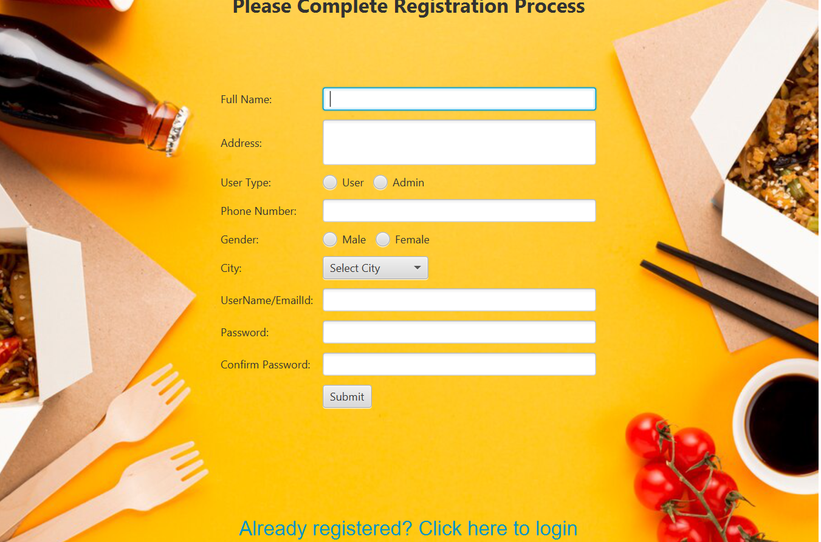

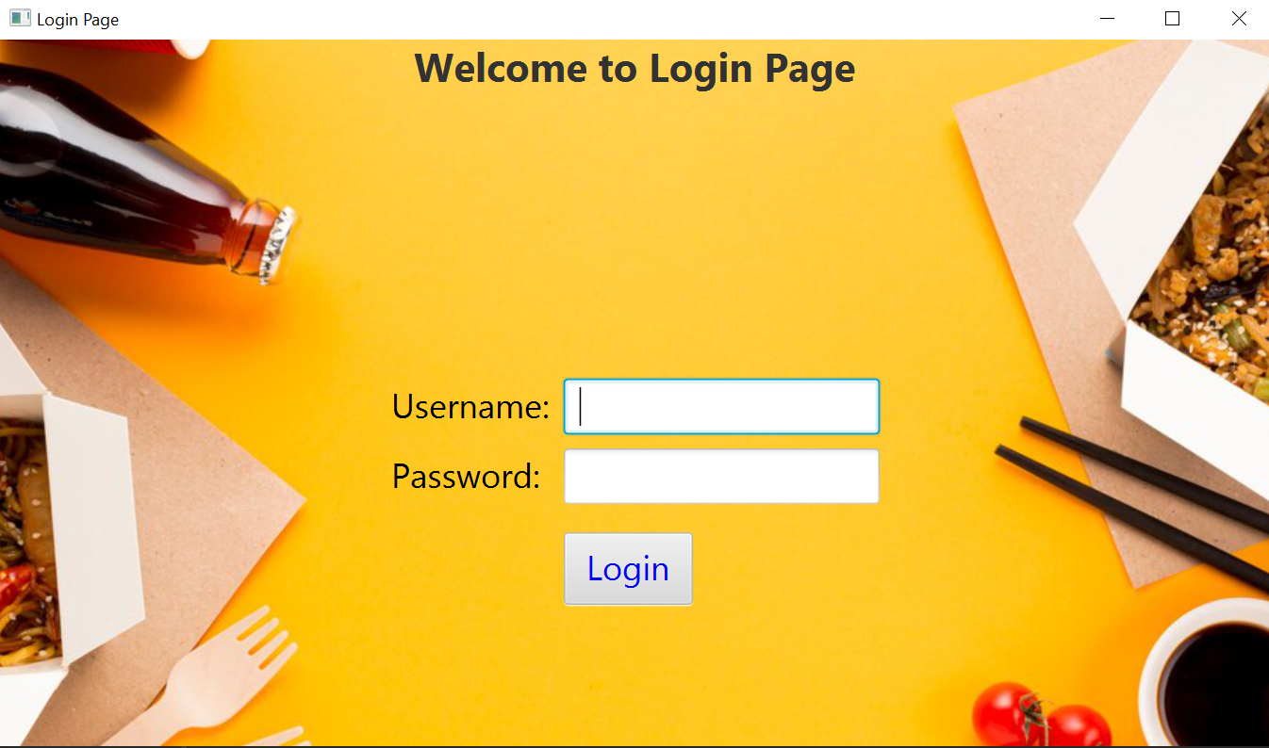

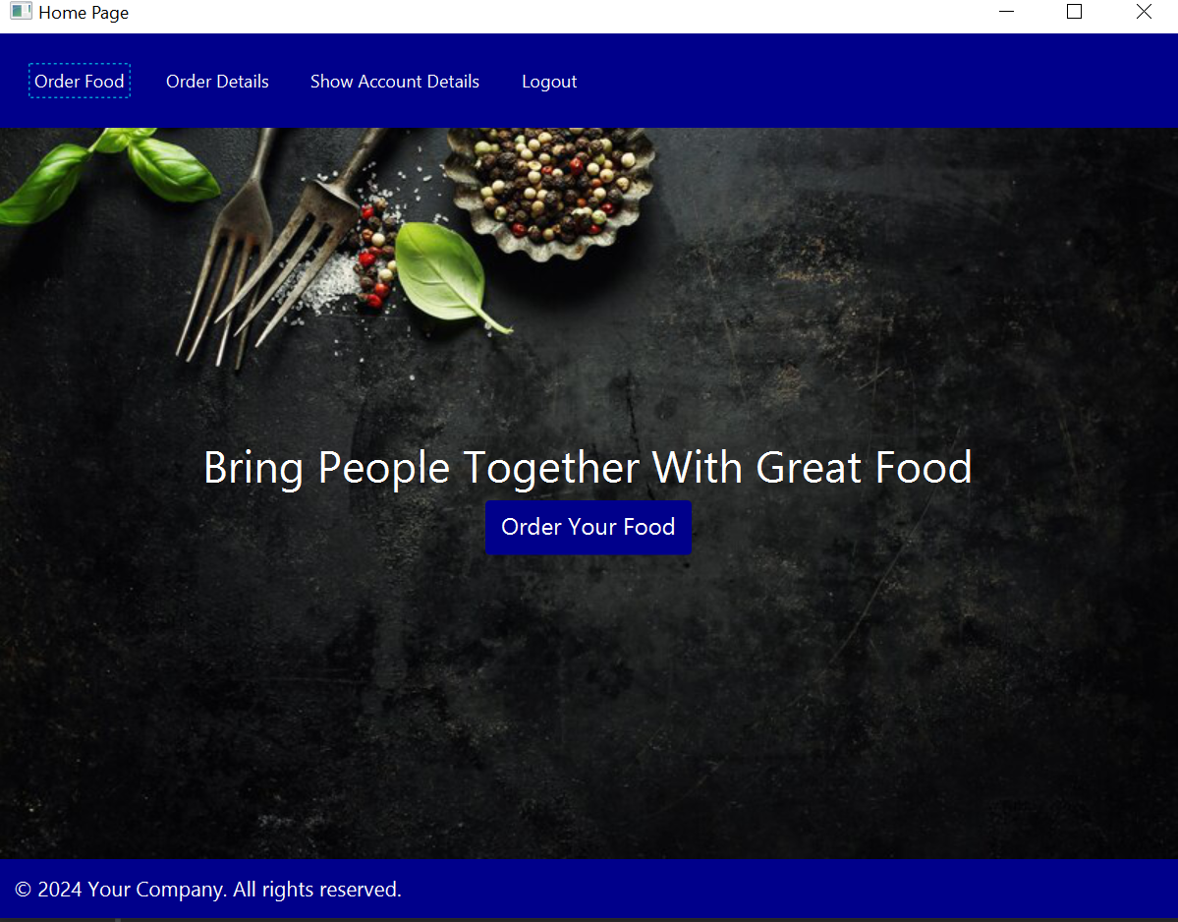

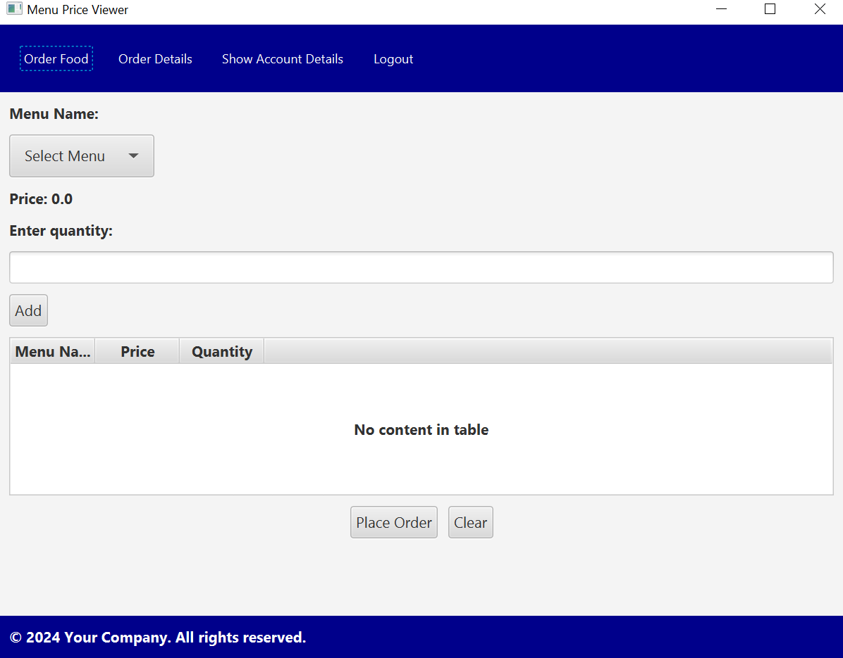

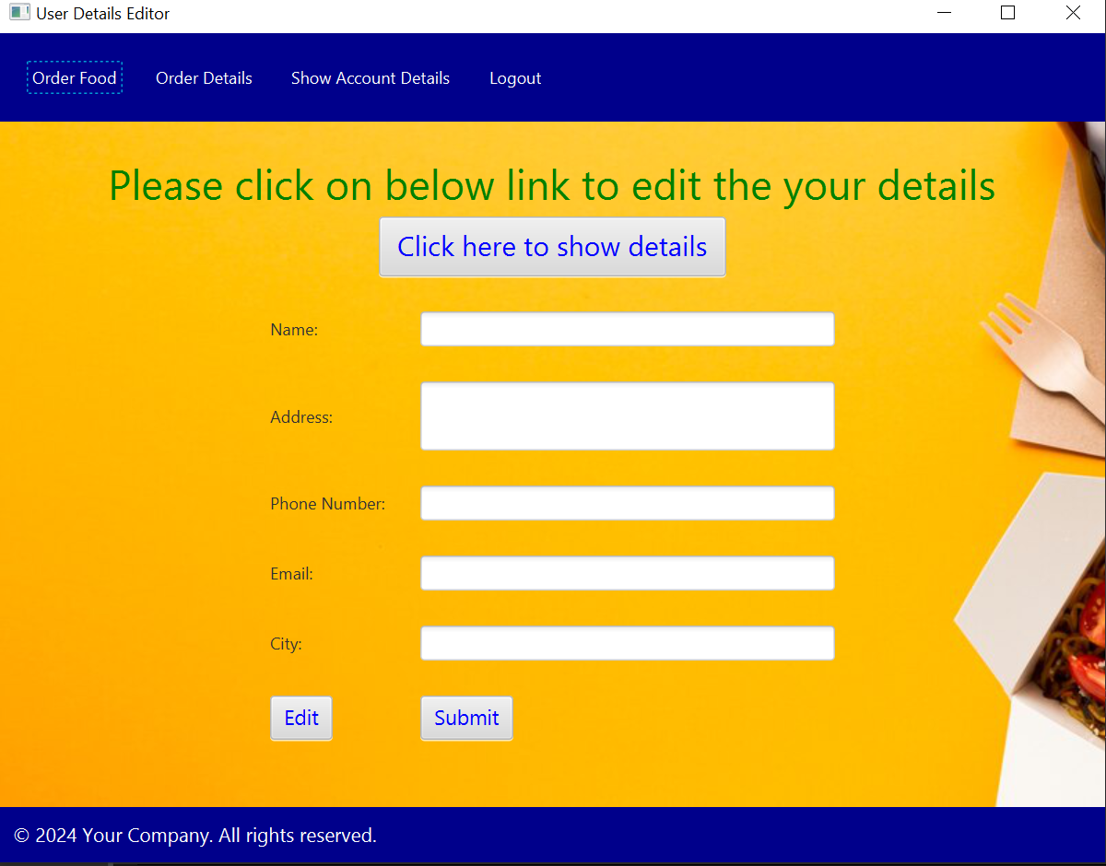

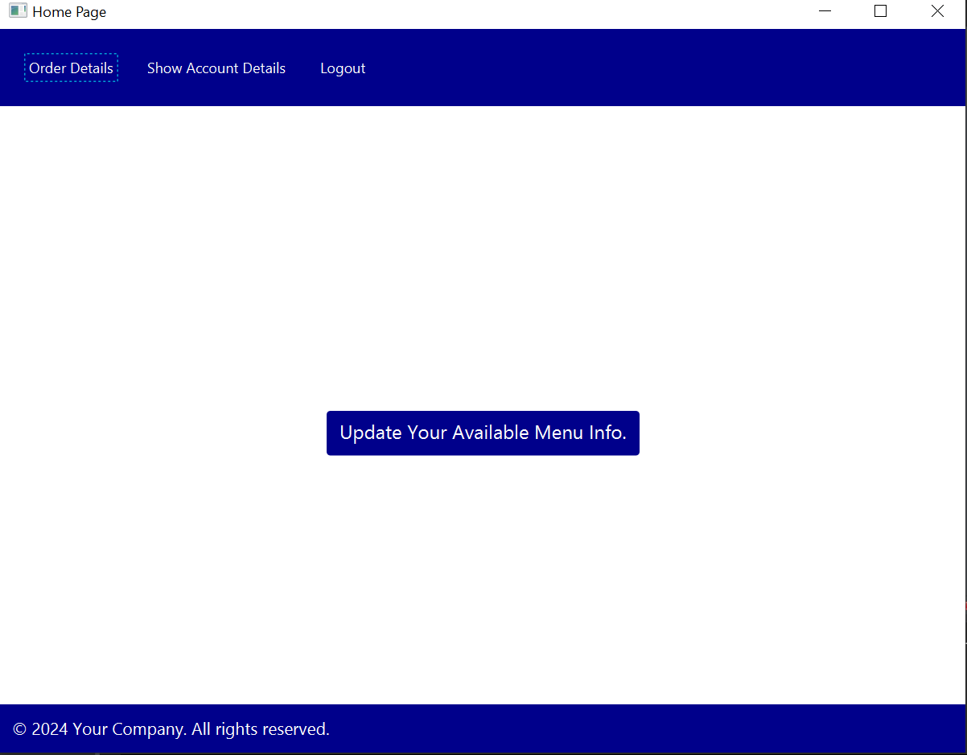Software testing is a component of the third phase, and means checking if a program for specified inputs gives correctly and expected results. So, the main aim of testing is to analyse the performance and to evaluate the errors that occur when the program is executed with different input sources and running in different operating environments.

∙ Goal of testing :-

                      Testing is an activity performed for evaluating software quality and for improving it. Hence, the goal of testing is systematically detection of different classes of errors (error can be defined as a human action that produces an incorrect result) in a minimum amount of time and with a minimum amount of effort.

 There are different types of approaches for testing a PHP framework-based application. The types of testing are :

# SYSTEM TESTING

METHODS OF TESTING:

 1. Unit testing: -

Unit testing is the approach of taking a small part of testable application and executing it according to the requirements and testing the application behaviour. Unit testing is used for detecting the defects that occur during execution.

When an algorithm is executed, the integrity should be maintained by the data structures. Unit testing is made use for testing the functionality of each algorithm during execution.

2. Validation testing: -

Validation is the process of finding whether the product is built correct or not. The software application or product that is designed should fulfil the requirements and reach the expectations set by the user. Validation is done while developing or at the final stage of development process to determine whether it is satisfies the specified requirements of user.

3. Integration testing: -

Integration testing is an extension to unit testing, after unit testing the units are integrated with the logical program. The integration testing is the process of examining the working behaviour of the unit after embedding with program. This procedure identifies the problems that occur during the

4. User Acceptance testing: -

User acceptance testing is the process of obtaining the confirmation from the user that the system meets the set of specified requirements. It is the final stage of project; the user performs various tests during the design of the applications and makes further modifications according to the requirements to achieve the result. The user acceptance testing gives the confidence to the clients about the performance of system.

 5. Black Box & White Box testing: -

Black box testing is the testing approach which tells us about the possible combinations for the end-user action. Black box testing doesn't need the knowledge about the interior connections or programming code. In the black box testing, the user tests the application by giving different sources and checks whether the output for the specified input is appropriate or not.

        White box testing is also known as "glass box" or "clear box" or "open box" testing. It is opposite to the black box testing. In the white box testing, we can create test cases by checking the code and executing in certain intervals and know the potential errors. The analysis of the code can be done by giving suitable inputs for the specified applications and using the source code for the application blocks.

# CONCLUSION

**1)Convenience: Online food delivery apps offer unmatched convenience, allowing users to browse through various cuisines, select dishes, and have them delivered to their doorstep with just a few taps on their smartphones.**

**2)Variety: These apps provide users with access to a wide range of restaurants and cuisines, catering to diverse tastes and preferences. Users can explore different options without limitations based on location.**

**3)Efficiency: Online food delivery apps streamline the ordering process, reducing the time and effort required for customers to enjoy their favourite meals. They also provide real-time tracking, ensuring transparency and timely deliveries.**

# REFERENCES

1. [***https://www.ubereats.com***](https://www.ubereats.com)
2. [**https://chat.openai.com/**](https://chat.openai.com/)
3. [**https://github.com/topics/online-food-order**](https://github.com/topics/online-food-order)
4. [**https://www.lovelycoding.org/online-food-ordering-system/**](https://www.lovelycoding.org/online-food-ordering-system/)